**Cartooning of real image in python**

Submitted in partial fulfilment of the requirements for the award of degree of

**BACHELOR OF ENGINEERING**

**IN**

**COMPUTER SCIENCE &ENGINEERING**



**Submitted to: Submitted by:**

**Er Amandeep Kaur KUMAR AAKARSHAN (18BCS6640)**

**RITIK DHAND (18BCS6661)**

**VANSHIKA (19BCS8002)**

**Mentor Signature (name and ecode)**



**DEPARTMENT OF COMPUTER SCIENCE & ENGINEERING**

**Chandigarh University, Gharuan**

**June 2021**

### CERTIFICATE

This is to certify that the work embodied in this Project Report entitled **“ Cartooning of real image in python”** being submitted by **“ KUMAR AAKARSHAN, RITIK DHAND, VANSHIKA ” -** UID **“ 18BCS6640, 18BCS6661, 19BCS8002 ” ,** 6th Semester for partial fulfillment of the requirement for the degree of **“ Bachelor of Engineering in Computer Science & Engineering ”** discipline in “ **Chandigarh University** ” during the academic session Jan-Jun 2021 is a record of bonafide piece of work, carried out by student under my supervision and guidance in the **“ Department of Computer Science & Engineering ”, Chandigarh University.**

**APPROVED & GUIDED BY: AMANDEEP KAUR**

### DECLARATION

### I, KUMAR AAKARSHAN student of Bachelor of Engineering in Computer Science & Engineering, 6th Semester , session: Jan – June 2021, Chandigarh University, hereby declare that the work presented in this Project Report entitled “ Cartooning of real image in python ” is the outcome of my own work, is bona fide and correct to the best of my knowledge and this work has been carried out taking care of Engineering Ethics. The work presented does not infringe any patented work and has not been submitted to any other university or anywhere else for the award of any degree or any professional diploma.

**Student details and Signature**

**NAME: KUMAR AAKARSHAN UID:18BCS6640**



**APPROVED & GUIDED BY: AMANDEEP KAUR**

To our parents, teachers and all the well wishers out there . . .

**Abstract**

Aim of the project is to put forward a solution for transforming snapshots of real-world into animated photos (Cartoon Images). The earlier method of transformation requires complicated computer graphics and skills. The idea of the paper is based on designated snapshots which are converted to an art form such as painting. Amongst all the techniques usable, the application of a OPEN CV called NUMPY will be used for the styling real-world images that use loss functions namely, content loss and adversarial loss for getting a sharp and clear image.

**Project Description**

1. **Introduction:**

Cartooning a digital image sounds a very interesting, fun and easy to work on. So as to achieve an animation picture from a digital image, we only need some bilateral filter and edge detection mechanism. These bilateral filters will assist us with reducing the color or shading palette of the image, which is an important step for the animation look, and edge detection are used to get a perfect bold silhouette.

In the past few years, image cartomizer-software has been used for converting the normal image into a cartoon image. In this process, edge detection and bilateral filter are required. The bilateral filter is used to reduce the color palette of an image. Afterward, we can apply edge detection to this image for generating a dark shaped image. Therefore, finally, some tricks can apply for this image to get a cartoon image.

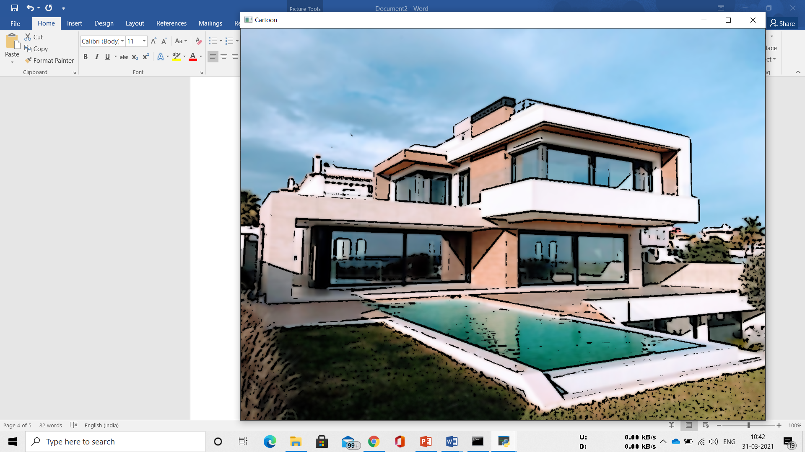

1. **Methodology/ Planning of work:**
2. The initial step of cartooning image is to apply the bilateral filter to decrease the shading or color palette of the image, which implies first we need to downscale the image and afterward apply the bilateral filter to get an animation flavor and again we upscale the image.
3. The next step is to get a blurred image of the real image. And we just need the blurring of the limits without colors to interfere in this process. So, for this, we first convert the genuine picture to grayscale.
4. The following stage is to apply the median blur so as to diminish image noise in the grayscale image.
5. Next, we make an edge mask from the grayscale image utilizing an adaptive thresholding technique.
6. In the last step, we have to recognize the edges in the image and afterward add this to the recently changed pictures to get cartoonish or sketch pen impact to the picture. After this step, we finally combine the final images obtained from the previous steps.
7. Here we get our cartoonist image.

**Technologies you will learn by working on Cartooning an Image using Open CV:**

* Image Processing
* Computer vision
* Python

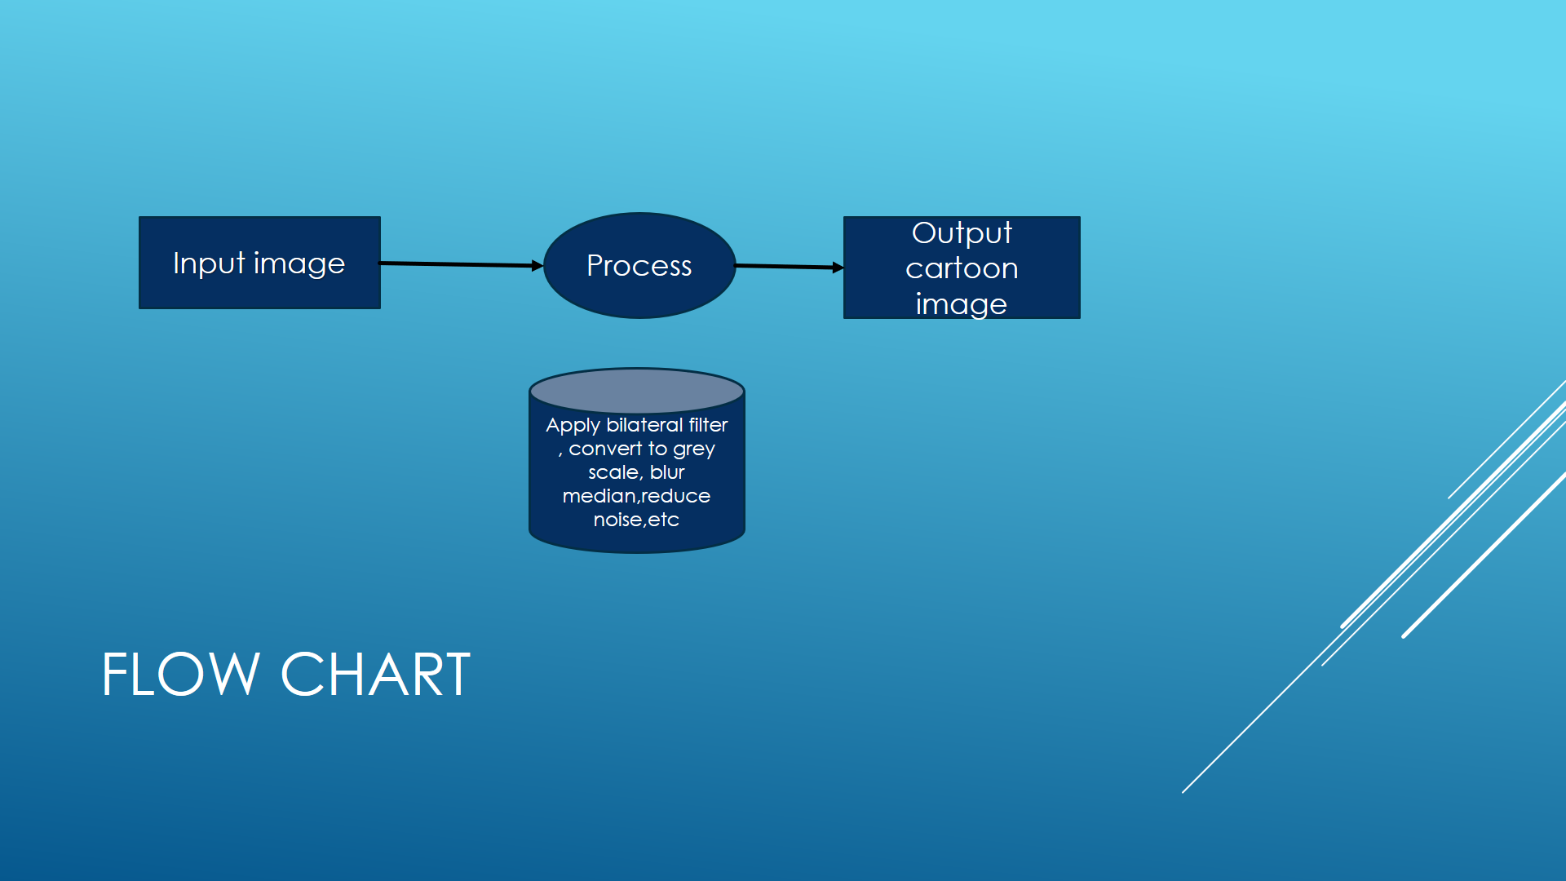

1. **Implementation (100%)**

* The initial step of cartooning image is to apply the bilateral filter to decrease the shading or color palette of the image, which implies first we need to downscale the image and afterward apply the bilateral filter to get an animation flavor and again we upscale the image.
* The next step is to get a blurred image of the real image. And we just need the blurring of the limits without colors to interfere in this process. So, for this, we first convert the genuine picture to grayscale.
* The following stage is to apply the median blur so as to diminish image noise in the grayscale image.
* Next, we make an edge mask from the grayscale image utilizing an adaptive thresholding technique.
* In the last step, we have to recognize the edges in the image and afterward add this to the recently changed pictures to get cartoonish or sketch pen impact to the picture. After this step, we finally combine the final images obtained from the previous steps.
* Here we get our cartoonist image.

**Snapshots:**

**Updating packages, and installing required module**

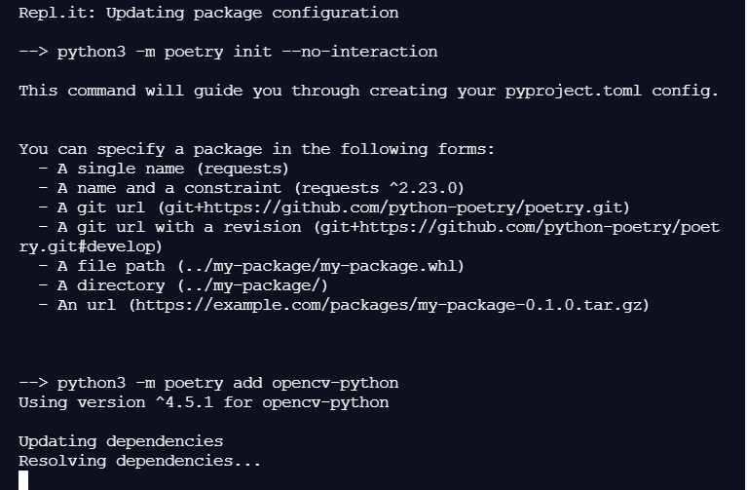

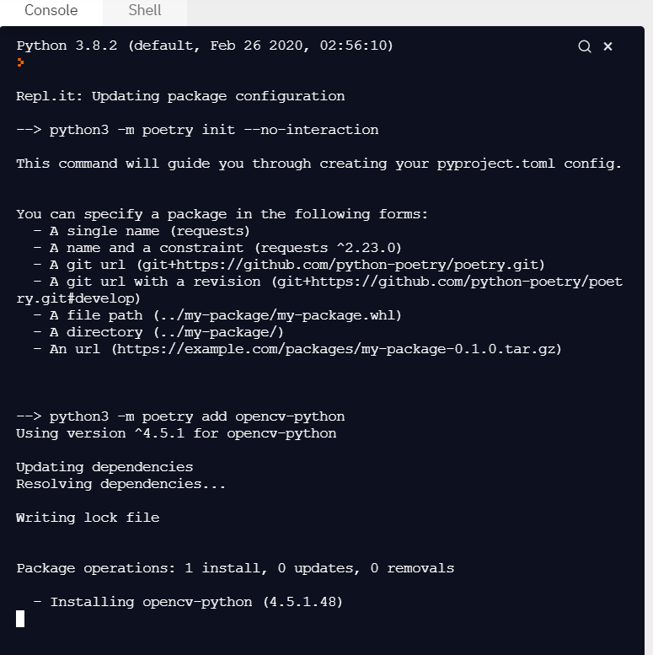

**Running the program on cmd.**

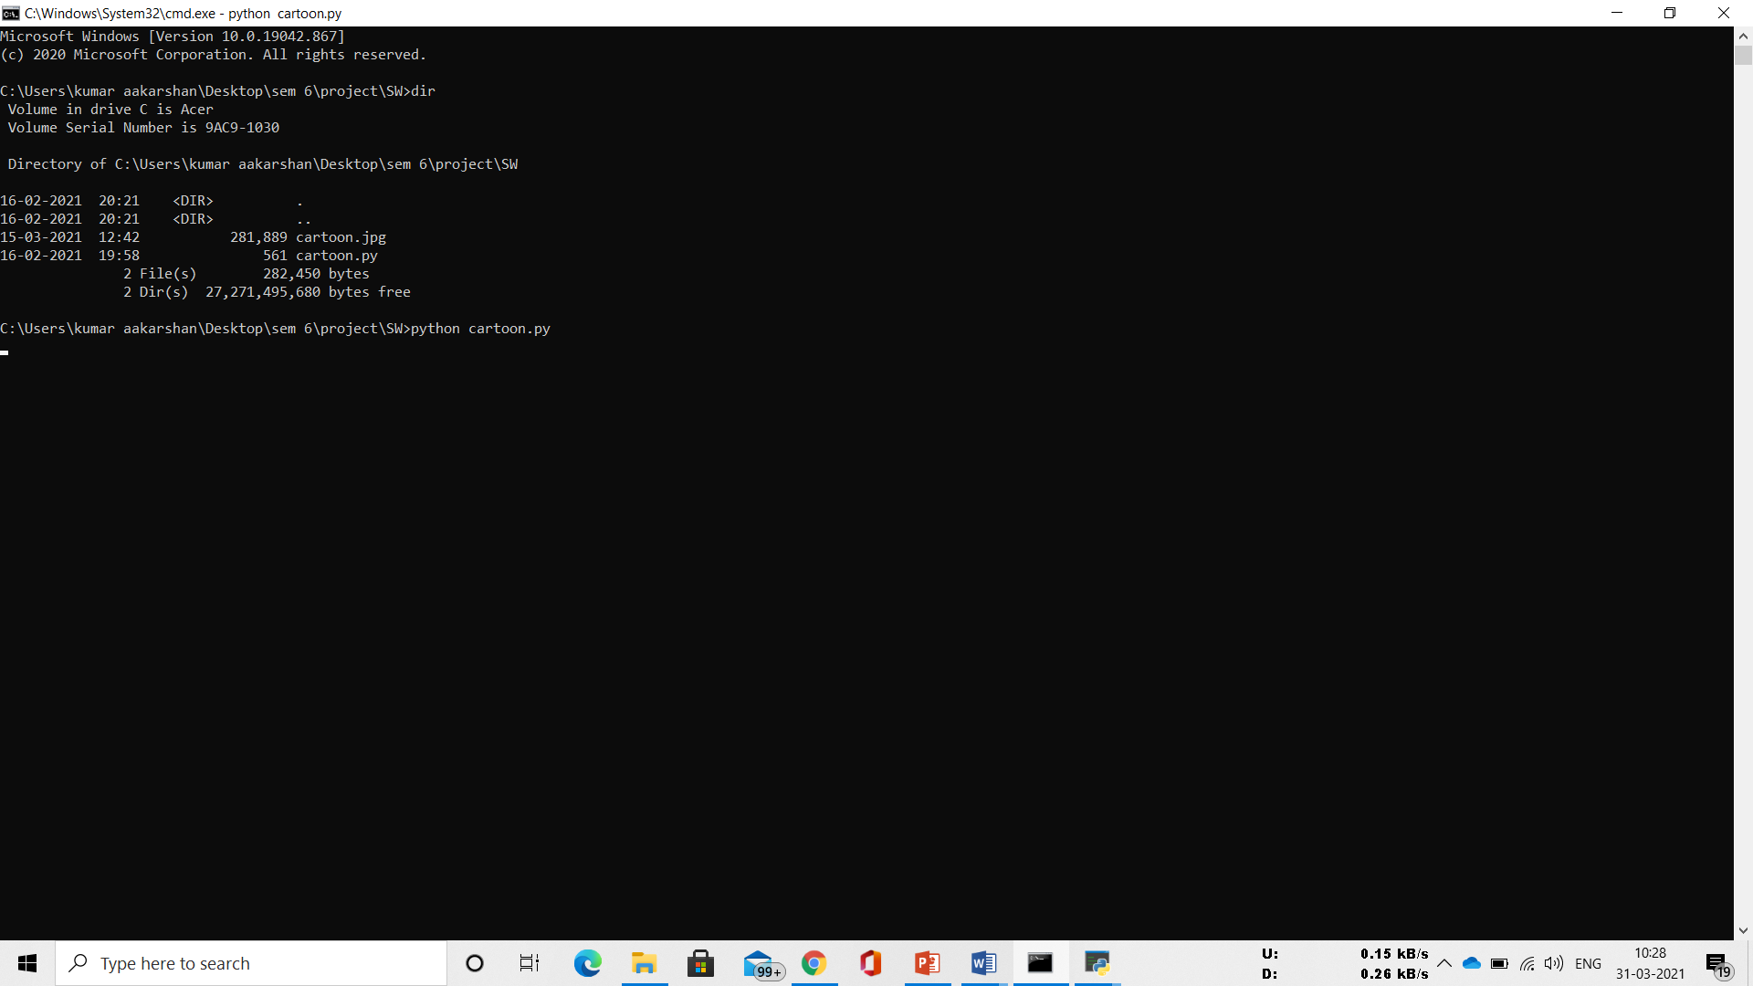

**Taking input file**

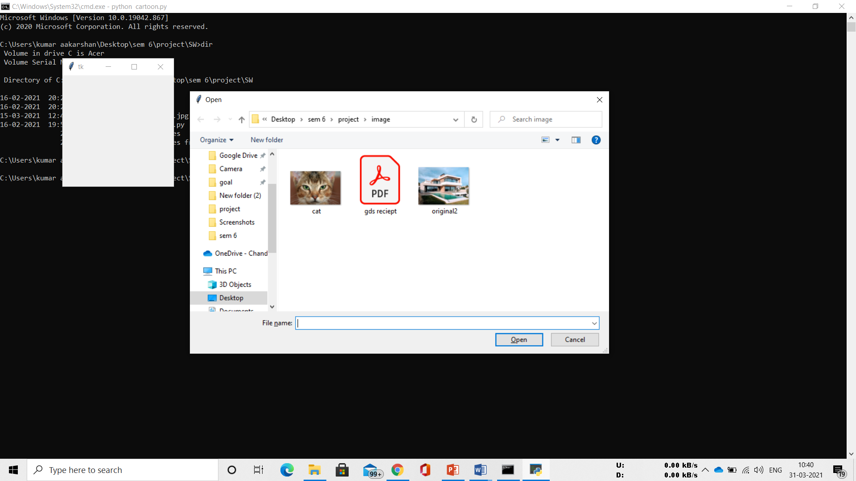

**Getting output file:**



1. **Output validation and comparison**

**Input vs Output comparison.**

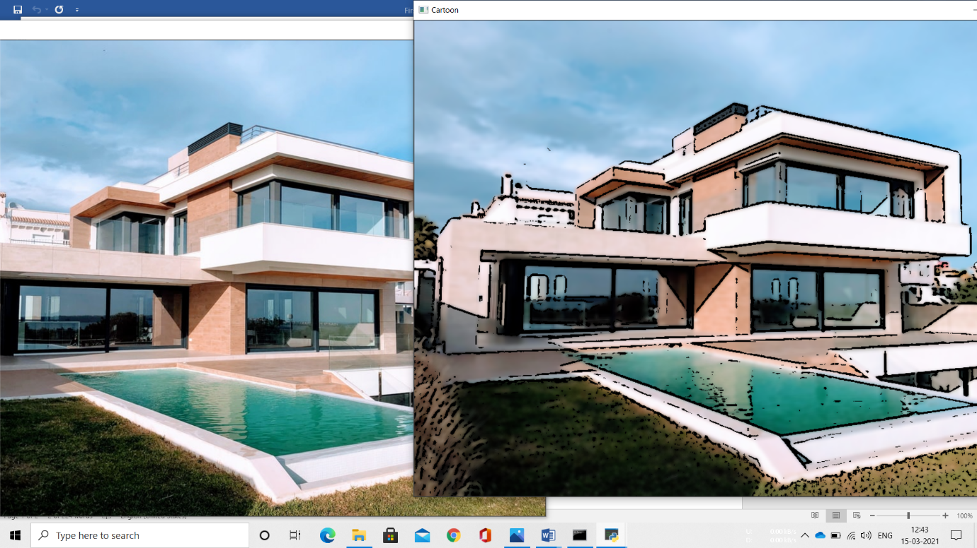

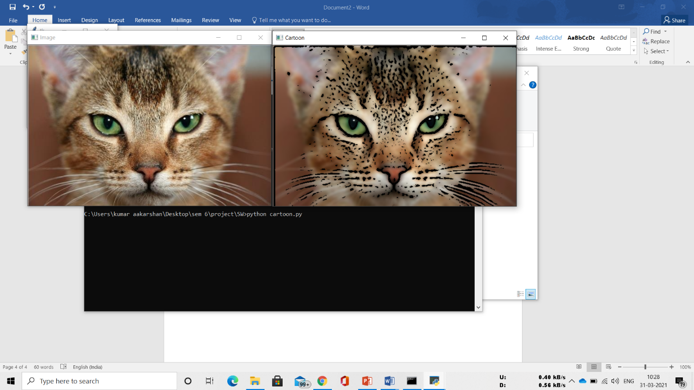

## **Results and Discussion**

In the past few years, image cartomizer-software has been used for converting the normal image into a cartoon image. In this process, edge detection and bilateral filter are required. The bilateral filter is used to reduce the color palette of an image. Afterward, we can apply edge detection to this image for generating a dark shaped image. Therefore, finally, some tricks can apply for this image to get a cartoon image.



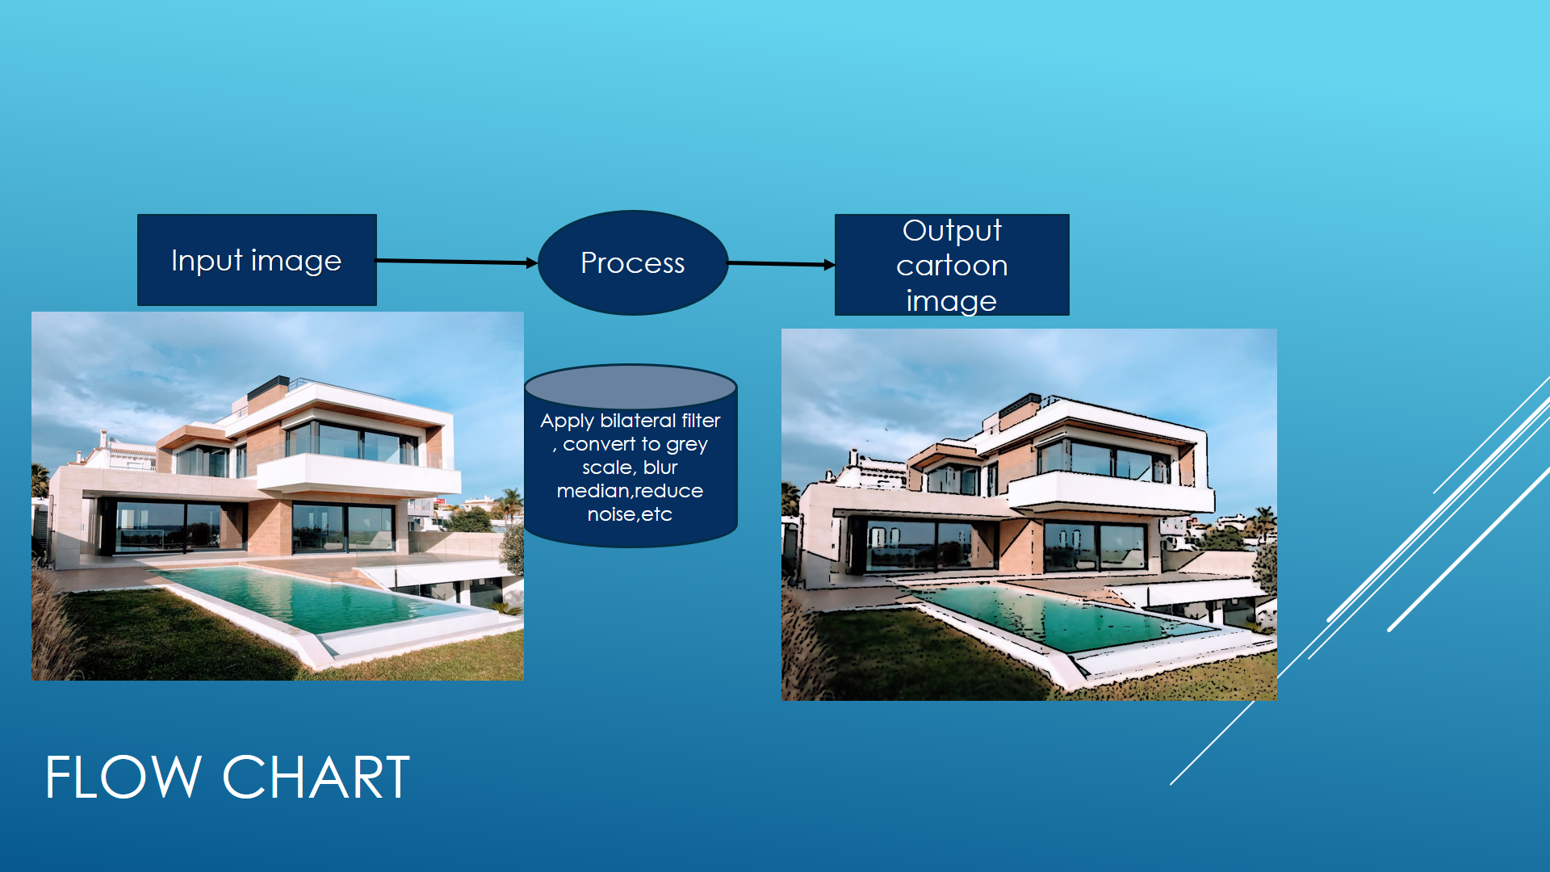

1. **CONCLUSION**

In this paper with the help of OPENCV,is used to transform images (snapshots) to the finest cartooned image(animated image ). With the help of the loss function and its two types named as Adversarial loss and Content Loss, we got a flexible as well as a clear edge defined images. Also with the help of CV which is known as Computer vision, we have TRANSFORMED IMAGE into cartoonistic image.





1. **REFERENCES**

* <https://www.skyfilabs.com/project-ideas/cartooning-an-image-using-open-cv>
* <https://www.elprocus.com/image-processing-projects-for-engineering-students/>
* <https://www.geeksforgeeks.org/cartooning-an-image-using-opencv-python/>
* <https://github.com/>